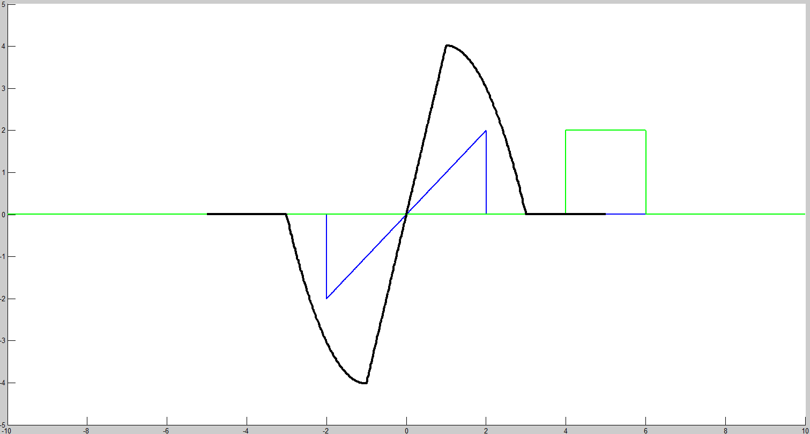

Convolución 1

Convolución 2

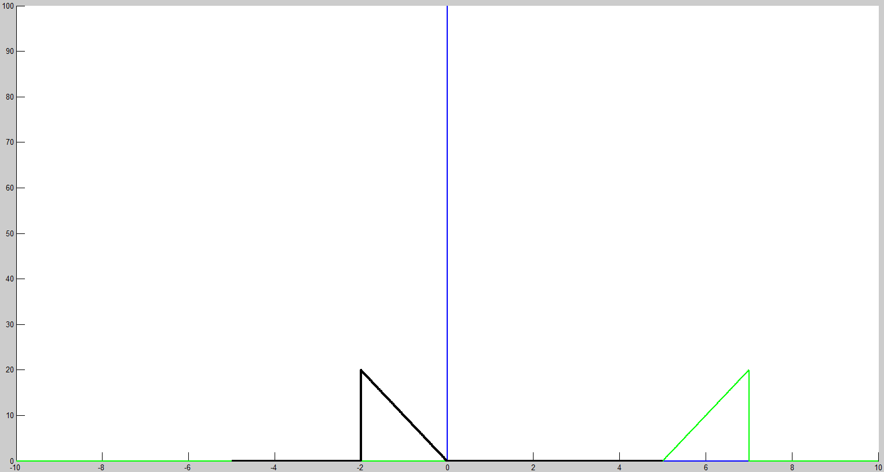

Convolución 3

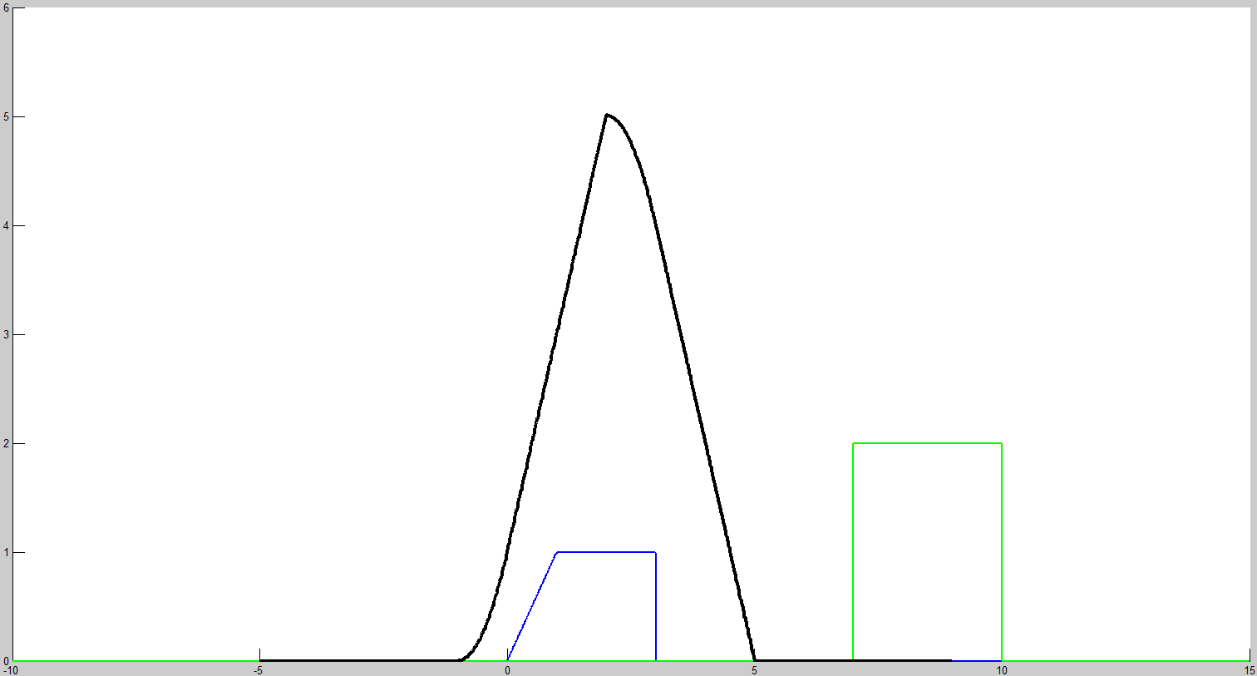

clc

clear all

close all

j=1;

t0=-5;

dt=0.01;

tf=9;

tao=-10:dt:15;

x1(length(tao))=0;

x1(length(tao))=0;

x2(length(tao))=0;

x2(length(tao))=0;

for t=t0:dt:tf

taom=tao-t;

for i=1:1:length(tao)

% if tao(i)>=-2 && tao(i)<=2 %%Señal 1) x1(t)

% x1(i)=tao(i);

% else

% x1(i)=0;

% end

% if tao(i)==0 %%Señal 2) x1(t)

% x1(i)=1/dt;

% else

% x1(i)=0;

% end

if tao(i)>=0 && tao(i)<=1 %%Señal 3) x1(t)

x1(i)=tao(i);

elseif tao(i)>1 && tao(i)<=3

x1(i)=1;

else

x1(i)=0;

end

end

for i=1:1:length(tao)

taom(i)<=1 %%Señal 1) x2(t)

% x2(i)=2;

% else

% x2(i)=0;

% end

% if taom(i)>=0 && taom(i)<=2 %%Señal 2) x2(t)

% x2(i)=10\*(taom(i));

% else

% x2(i)=0;

% end

if taom(i)>=-2 && taom(i)<=1 %%Señal 3) x2(t)

x2(i)=2;

else

x2(i)=0;

end

end

T(j)=t;

C(j)=sum(x1.\*x2.\*dt);

j=j+1;

hold on

plot(tao,x1,'b','LineWidth',2);

plot(tao,x2,'g','LineWidth',2);

plot(T,C,'k','LineWidth',3);

pause(0.0001)

if t<tf

cla

end

end